**Name: Sandeep Kumar UID- 20BCS4885**

**Section: 30/b Subject- Foundation of -IOT**

**Aim:** Hands-on session on Breadboard and Simulation Software.

**Requirements:** PC with Arduino, connecting wires, Breadboard, resistances.

**Theory:** A breadboard is a rectangular plastic board with a bunch of tiny holes in it. These holes let you easily insert electronic components to prototype (meaning to build and test an early version of) an electronic circuit, like this one with a battery, switch, resistor, and an LED (light-emitting diode).

**Screenshot 1:**

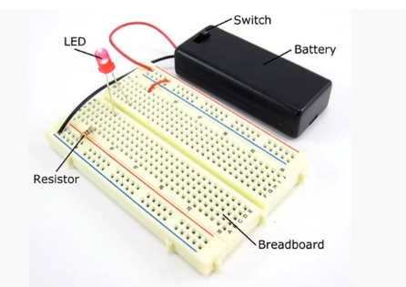

The connections are not permanent, so it is easy to remove a component if you make a mistake, or just start over and do a new project. This makes breadboards great for beginners who are new to electronics. You can use breadboards to make all sorts of fun electronics projects, from different types of robots or an electronic drum set to an electronic rain detector to help conserve water in a garden, just to name a few.

**Screenshot 2:**

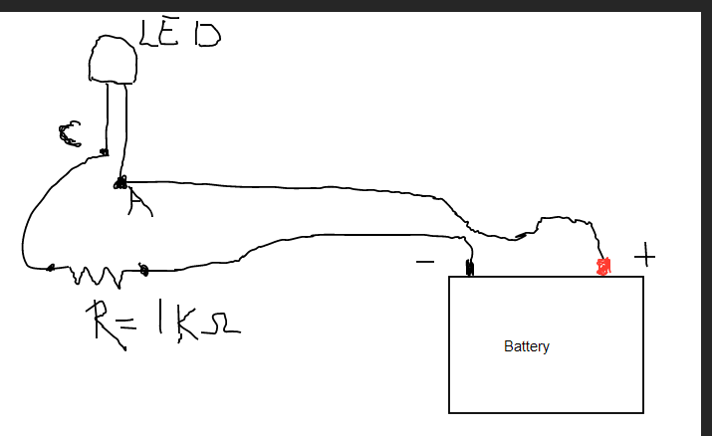

**Screenshot 3:**

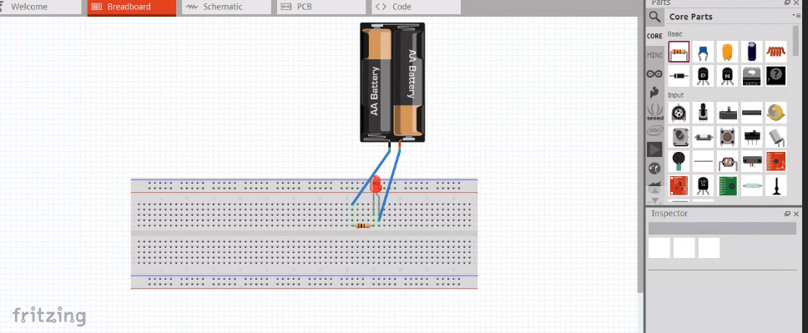

Evaluation Column (To be filled by concerned faculty only):

|  |  |  |  |
| --- | --- | --- | --- |
| **Sr. No.** | **Parameters** | **Maximum Marks** | **Marks Obtained** |
| 1. | Worksheet completion including writing learning objectives/Outcomes. (To be submitted at the end of the day) | 10 |  |
| 2. | Post Lab Quiz Result. | 5 |  |
| 3. | Student Engagement in Simulation/Demonstration/Performance and Controls/Pre-Lab Questions. | 5 |  |
| 4. | Total Marks | 20 |  |
| 5. | Teacher’s Signature (with date) |  | |